Jordan Estrada

SER 316

11/26/2018

Assignment 6

BUILDER PATTERN

The first pattern in my project is the builder pattern. BeeHiveBuilderInterface.java provides he simple interface for all types of bee hives. BeeHiveBuilder.java is the concrete class implementing BeeHiveBuilderInterface.java, which assembles a specific bee hive. BeeHiveBluePrint.java sets up an interface for defining methods that will be set up and implemented in BeeHive.java, the concrete class containing the getters and setters. Finally, BeeHiveEngineer.java creates our bee using the methods specified in BeeHiveBuilderjava. This package satisfies the requirement “A beehive should have rooms for spawning more bees.” & “Bees should have to rest every so often” having rooms for resting.

DECORATOR PATTERN

Next is the decorator pattern. BeeInterface stores the three methods returning the bee attributes. BlankBee.java is the concrete class setting up a blank bee that will be decorated. BeeDecorator then wraps our bee in the various decorator classes adding attributes to our bee. This package satisfies the custom requirement of warrior, worker, and queen bees having distinct speed & strength.

FACTORY PATTERN

Next is the factory pattern. Bee.java is the abstract class our factory will be populating based on the bee type selected at runtime. BeeFactory.java then uses the string provided at runtime to pump out a bee using either QueenBee.java, WarriorBee.java, or WorkerBee.java. This package satisfies the custom requirement of the different bee types having different abilities.

SINGLETON PATTERN

Lastly, the singleton package only has the Apiary.java class, which only lets one apiary object exist. This package satisfies the requirement “An apiary can have many beehives in them. For this assignment, only ever allow one apiary to exist.”

HOW TO RUN MAIN

The main class demonstrating each pattern is found in the default package in the src folder and is very simple to use. When ran, first two hashcodes are shown in the console. This is the singleton package demonstrating that only one apiary object was able to be created. Next, our builder package assembles a beehive and uses getters to show the bee type housed in the hive, the hive size, whether the hive has resting rooms, and whether the hive has spawning rooms. Next, the factory package is demonstrated. The user is prompted to select a bee type to be created. If the user enters anything else, “Invalid Input” will be shown until the user enters a valid input. Once a bee is selected, the console will show its assembly, and then show the bee type, strength points, and speed points.

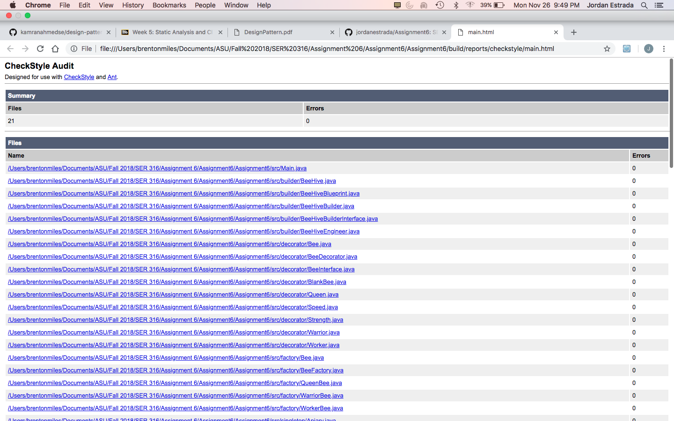

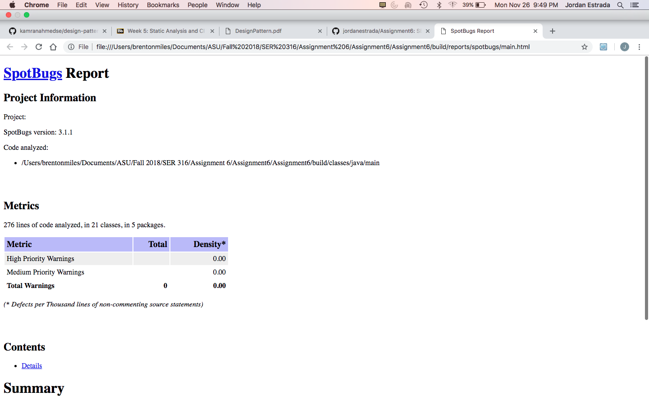

the repository for my project can be found at: https://github.com/jordanestrada/Assignment6